**Illustrate the structure of website.**

The purpose of a website is to present valuable information in an accessible way. This information is distributed amongst various internal pages that make up a website. Website structures define the architecture of a website for search engines and users alike.

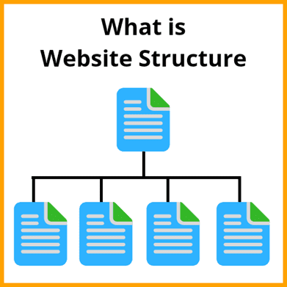

The structure of a website basically means how all the different pages on a website are connected to each other. This can be accomplished using internal links, which present the hierarchy and organization of your website to the search engine algorithms.

**Website Structure**

WebSite structure or website architecture refers to how your website is designed or how various pages on your website are connected for excellent user experience. This is important not just from the user’s perspective but also for [search engine optimization](https://www.infidigit.com/blog/what-is-seo/).

**What are the types of website structure?**

* **Hierarchical Model**

This is the most common and preferred type of website structure. This is also known as a tree structure, where there is a parent page with a broad set of information, and it is further categorized into child pages with detailed information.

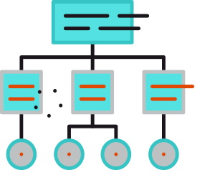

* **Sequential Model**

As the name says, this allows the user to browse in a sequential manner. Here, the user can only travel in a forward or backward direction.



* **Matrix Model**

This was popularly used in the early years of the internet. It provided the user with many relevant links under various topic groups, allowing them to choose where they wanted to go next.



* **Database Model**

This is a dynamic approach to website architecture, integrating a database with a search. With this website structure, users can create experiences based on their search query.

